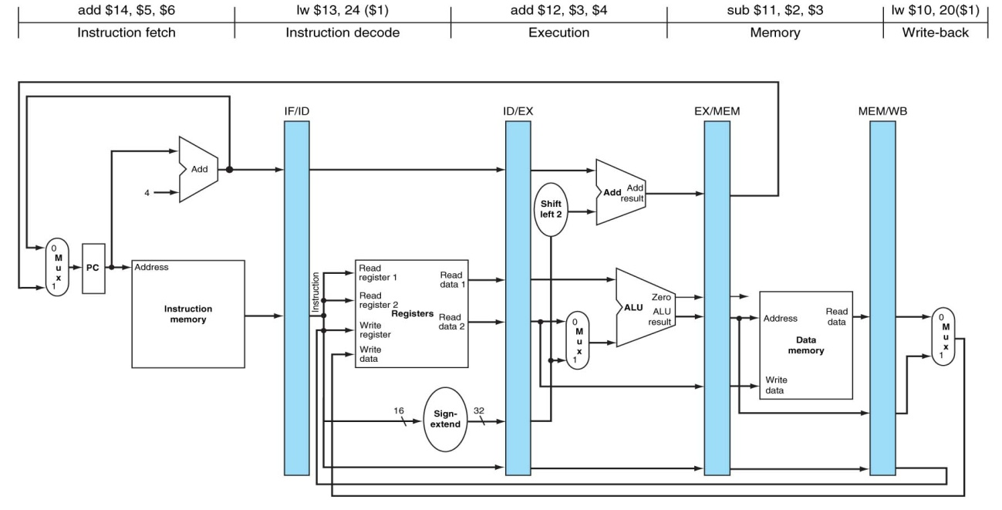

ENUNCIADO **PROBLEMA 3**:

**$8 = 3**

**$**9 = 16

**$10 = 2**

**$12 = 1**

**MEM[20]** = 200

**Método utilizado para resolver los riesgos de datos**: bloqueo, anticipación.

|  |  |  |  |  |  |  |  |  |  |
| --- | --- | --- | --- | --- | --- | --- | --- | --- | --- |
|  | **Ciclo 1** | **Ciclo 2** | **Ciclo 3** | **Ciclo 4** | **Ciclo 5** | **Ciclo 6** | **Ciclo 7** | **Ciclo 8** | **Ciclo 9** |
| **$8** | 3 | 3 | 3 | 3 | 3/200 | 200 | 200 | 200 |  |
|  |  |  |  |  |  |  |  |  |  |
| **EX/MEM** | X | X | X | 20 | 20 | 202 | 0 | 0 |  |
| **MEM/WB** | X | X | X | X | 200 | 200 | 202 | 0 |  |
| **LW $8, 4($9)** | MI | REG  $9=16  4 | ALU  EX/MEM🡨4+16=20 | MD  MEM/WB🡨MD[EX/MEM]  =MD[20]=200 | REG  $8🡨MEM/WB=200 |  |  |  |  |
| **ADD $11, $8, $10** |  | MI | REG  $8=3  $10=2 | --- | ALU  EX/MEM🡨2+MEM/WB  =2+200=202 | MD  MEM/WB🡨EX/MEM  =202 | REG  $11🡨MEM/WB=  =202 |  |  |
| **SUB $12, $12, $12** |  |  | MI | --- | REG  $12=1 | ALU  EX/MEM🡨1-1=0 | MD  MEM/WB🡨EX/MEM  =0 | REG  $12🡨MEM/WB=0 |  |
| **Comentarios** |  |  | Lectura errónea de $8 | Se produce BURBUJA | 1er Semiciclo cambia de valor, 2º semiciclo usable  Anticipación desde MEM/WB |  |  |  |  |